Array in Java

Assignment

Question 1- What is the default value of Array for different data types?

Ans-

The default value of Array depends on its data type.

For numeric data types (byte, short, int, long, float, and double ), the default value is 0.

For the boolean data type, the default value is false .

For the char data type, the default value is the null character, ‘\u0000’.

For object data types, such as string or any user-defined class, the default value is null.

For example, consider the following code snippet:

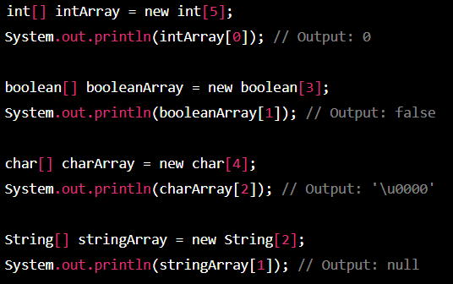

In the above code, I have just initialized arrays of different data types with a specific size, and we are printing the value of their first index. As we can see, the default value for each data type’s array is as mentioned above.

Question 2- Can you pass the negative number in Array ?

Ans-

Yes, we can pass negative numbers in an array in Java. An array is a data structure that can hold a fixed number of elements of the same type. The type of the elements in the array can be any of the primitive types, including int, which is used to represent integer, both positive and negative.

To pass a negative number in an array, you can simply assign the negative value to the desired element in the array. For example, consider the following code snippet that declares and initializes an array with both positive and negative integers:

int[] myArray = {1, -2, 3, -4, 5};

In this example, the array “myArray” has five elements, where the second and fourth elements

Are negative integers (-2 and -4,respectively). You can then pass this array to a method or use it in your program as needed.

Noting that the process of passing an array is the same regardless of whether the array contains negative or positive numbers.

Question 3- Where does Array stored in JVM memory ?

Ans-

When an array is created , it is stored in the Java Virtual Machine (JVM) . The heap memory is a region of memory used for dynamic memory allocation by the JVM. When an array is created, memory is allocated from the heap to hold the array elements.

The size of the memory allocated for an array depends on the number of elements in the array and the size of each element. For example, an array of integers would require more memory than an array of bytes, as each integer takes up more memory than each byte.

Question 4- What are the disadvantages of Array ?

Ans-

Array are useful data structures that allow you to store a fixed number of elements of the same data type. While they have many advantages, they also have some disadvantages.

Here are some of the disadvantages of arrays .

1. Fixed Size: One of the main disadvantages of arrays is that they have a fixed size. Once an array is created, its size cannot be changed. This means that if you need to store more elements than the size of the array, you will need to create a new array and copy the elements from the old array into the new one.
2. Sequential Access: Accessing elements in an array is typically done sequentially.If you need to access an element in the middle of the array, you must iterate through all the preceding elements, which can be slow for large arrays.
3. Homogeneous Elements: Arrays can only hold elements of the same type. If you need to store elements of different data types, you must use a different data structure or create an array of objects.
4. No Build-in Methods: Arrays do not have built-in methods for common operations like adding or removing elements. This can make it more difficult to manipulate arrays and perform common tasks.
5. Performance: Some operations on arrays can be slow in terms of performance, especially when searching or sorting large arrays.

Overall, while arrays have their uses in programming, they are not always the best choice for every situation. Other data structures like lists, sets, and maps may be better suited to certain tasks.

Question 5- What is an Anonymous Array in Java? Give an example ?

Ans-

In Java, an anonymous array is an array that is created without assigning it to a named variable. Anonymous arrays are created on the fly, as a part of an expression, and are useful when you need to create an array for a short-term use and don’t want to bother with assigning a name to it.

Here’s an example of an anonymous array in Java:

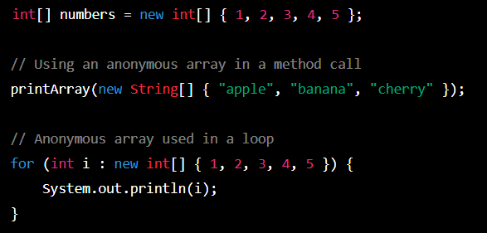

In the first line of code , we create an array of integers and assign it to a named variable called ‘number’ . However, in the next two examples, we use anonymous arrays.

In the second example, we pass an anonymous array of strings to a method called ‘printArray’ . The method takes an array of string as an argument, but instead of creating a named array and then passing it to the method, we create an anonymous array on the fly and pass it directly to the method call.

In the third example, we use an anonymous array in a for loop. The loop iterates over the array of integers, but instead of creating a named array and then using it in the loop, we create an anonymous array on the fly and use it directly in the loop.

Question 6- What are the different ways to traverse an Array in java?

Ans-

There are several ways to traverse an array in java, including:

1. Using a for loop:

One of the most common and simple ways to traverse an array. You can use a for loop to

iterate through each element in the array.

Example:

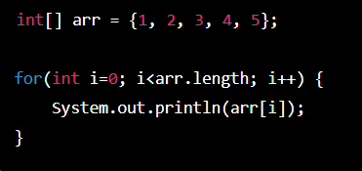

2.Using a for-each loop: This is another way to traverse an array. It is also known as an enhanced for loop. It simplifies the code by removing the need for an index variable.

Example:

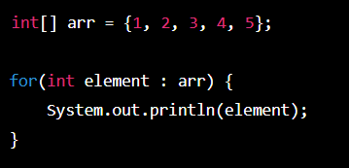

3. Using a while loop: You can also use a while loop to traverse an array. You need to set an index variable before entering the loop, and then increment the index variable inside the loop.

Example:

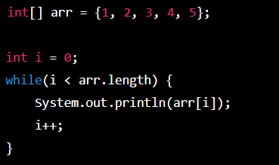

4. Using a do-while loop: This is another way to traverse an array. It is similar to the while loop, but the loop body is executed at least once.

Example:

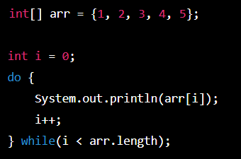

These are the different ways to traverse an array in Java. You can choose the one that suits your needs and coding style.

Question 7- What is the difference between length and length() method Give an Examples?

Ans-

“Length” and “length()” are two different concepts in programming, and the difference between them depends on the context in which they are used.

1. Length:

“Length” is a property or attribute of an object that refers to the number of elements, items, or characters that the object contains. The concept of length is commonly used with arrays, strings, and other collections. In this case, “length” is often accessed directly as a property of the object, without the need for parentheses.

Example:

Consider an array in JavaScript:

let arr = [1, 2, 3, 4, 5];

To get the length of this array, you can access the ‘length’ property directly:

console.log(arr.length); // 5

Here, the output will be 5, which is the number of elements in the array.

1. length() method:

“length()” is a method or function that is used to determine the length or size of a string or collection of elements. The length() method is commonly used in programming languages like Python and Java, where it is used to find the length of a string or the number of elements in an array.

Example:

Consider a string

